25.10: a) 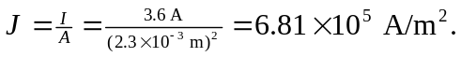
b)
c) Time to travel the wire’s length:
